8th July 2019

**WTCR Race of Portugal - Monteiro Strikes back**

Tiago Monteiro was the hero of Portugal at the weekend following his emotionally-charged home win in the WTCR – FIA World Touring Car Cup in Vila Real. The series which has Japanese Premium tyre manufacturer YOKOHAMA as exclusive tyre supplier witnessed the superb achievement of Monteiro, who suffered serious head and neck injuries in a testing crash in September 2017 and fought a long and arduous recovery.

Monteiro took the lead when Honda-powered KCMG team-mate Attila Tassi hit trouble with a spark plug issue, and managed to hold his nerve to the finish for his first victory since he triumphed in Hungary two years ago.

Behind Monteiro, Yvan Muller finished second for Cyan Racing Lynk & Co with nephew Yann Ehrlacher joining him on the podium for the first time in a second Lynk & Co 03 TCR. Afterwards, Muller explained that it had been difficult decision to race following the sad passing of a team technician, who suddenly felt ill. Both drivers paid tribute following the podium, while a minute’s silence was observed on the grid before Race 2.

Following his Race 1 victory, Norbert Michelisz also took valuable points from Vila Real and now stands only 25 points behind Esteban Guerrieri, current overall leader.

Other highlights of the weekend racing in Vila Real included the Inaugural WTCR win by Mikel Azcona, who took his maiden victory ahead of Ma Qinghua and Guerrieri in Race 2, which also proved an unhappy one for points leader Guerrieri. The ALL-INKL.COM Münnich Motorsport driver only started P16 after a sensor problem in qualifying, then endured a misfire in the race – allowing Michelisz to close the gap at the top.

*YOKOHAMA wishes to express its condolences to the family and friends and the WTCR Motorsports fraternity for the sad passing of the young Cyan Racing Lynk & Co. team member.*

The WTCR series travels to China – Ningbo, for the next race on 13-15 September, which is the beginning of the Asian rounds.

Current Driver Standings:

1. Esteban Guerrieri 231 pts
2. Norbert Michelisz 207
3. Thed Björk 181

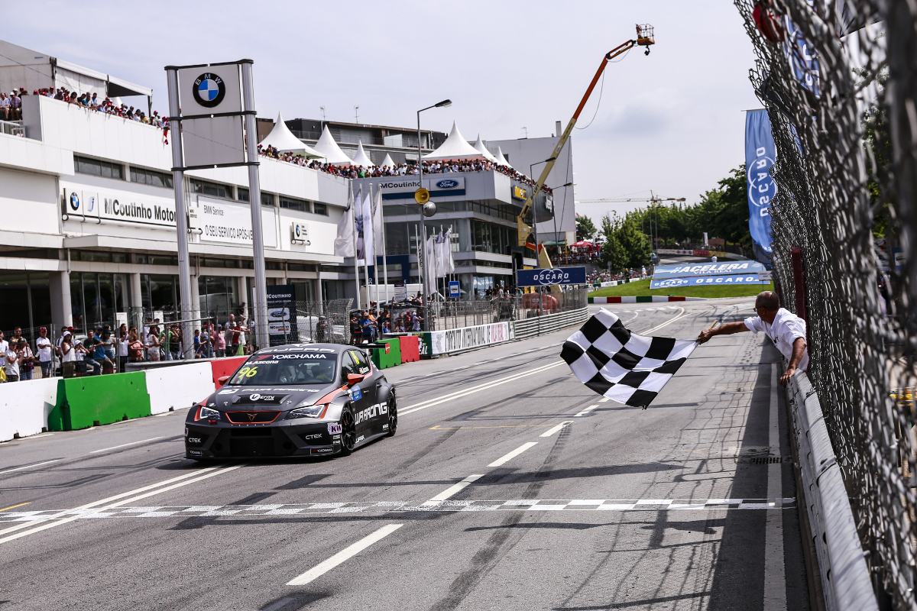

*Maiden victory for Azcona photo Xavi Bonilla*

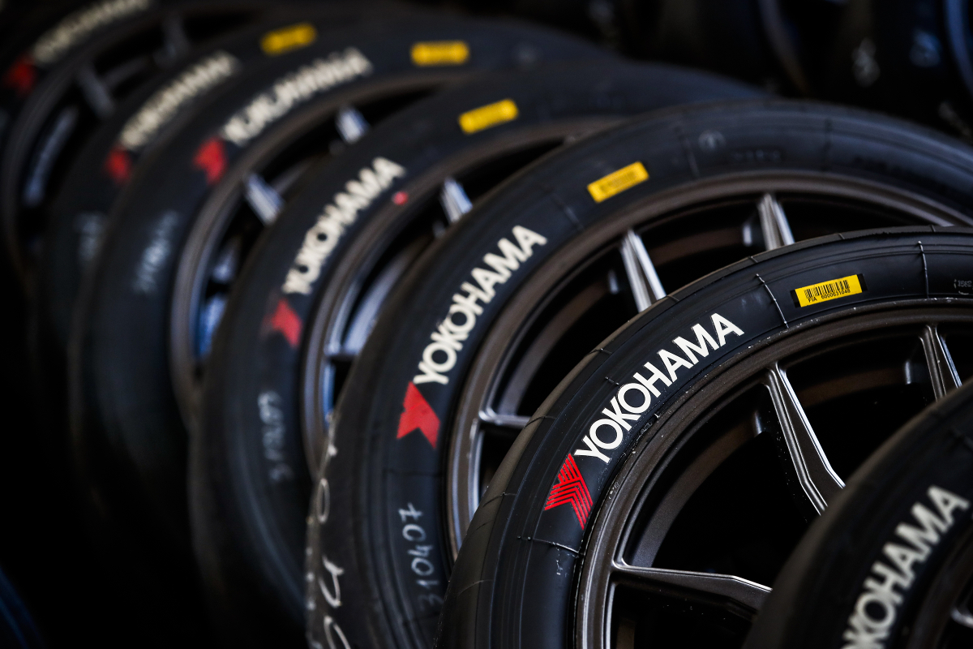

*WTCR Yokohama Tyres Photo Florent Gooden*

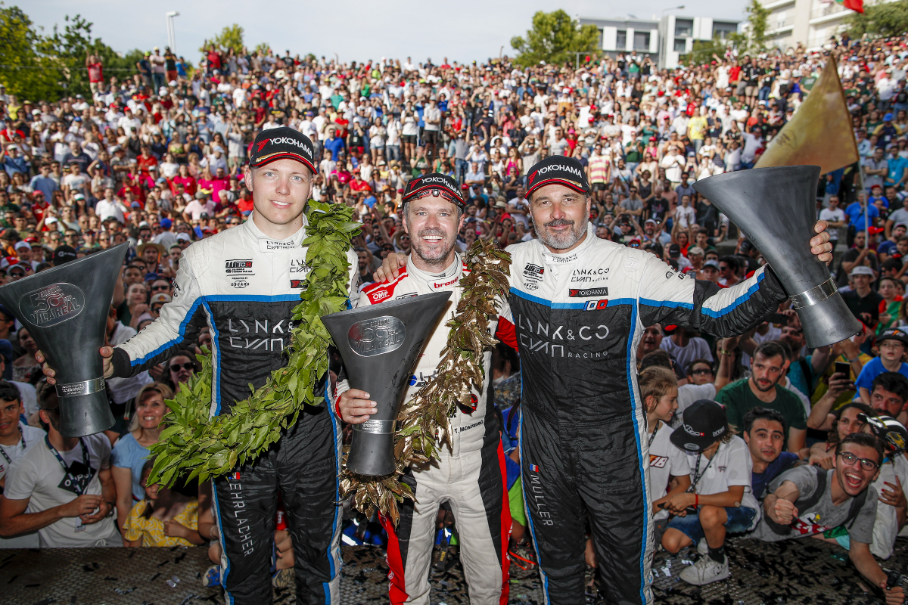

*Monteiro strikes back photo Florent Gooden*